Thursday Renju Class in 5lin.

- 教育訓練組 對 ○助教
Opening i11.
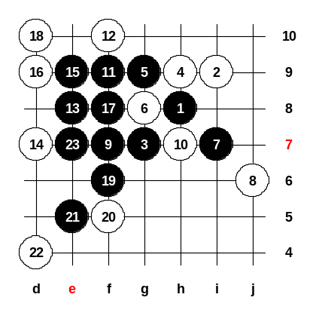

May 11 23:21
There is only one possible 6th move, 6-i7. But lets first try the wrong 6th move to g8. Black can win with starting with 7-i7. Now, black wins by VCF after 17th move. This example game shows that white other 6th moves are losing fast except 6-i7.

May 11 23:22
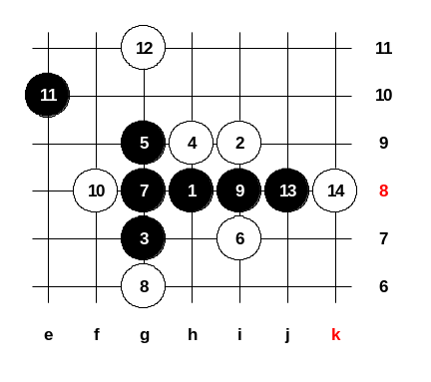
So, we will continue learning about the correct 6th move, 6-i7. In fact, black has five choices here for the 7th move - i10, f8, i8, g10, g8. Lets begin with the weakest 7th move - 7-g8. The 8-g6. Move 8-g10 is really bad, so 8-g6 is necessary. Black 11-e10. White has a good move here, 12-g11, remember it. Must 13-j8. And now black can continue attack on the left side. But it is not dangerous. If white makes careful defense moves then black attack fails very soon. This is the reason why people seldom play this 7th move. Sometimes, some people still like to play this move, because it contains many traps. One of the traps is to hope that white plays wrong 8th move, so black has a chance to win. Let’s set up the homework position to the new board now.

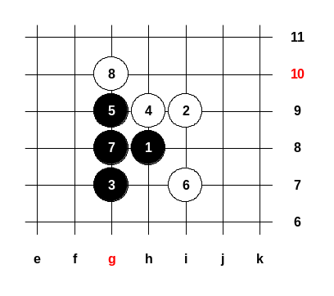
May 11 23:23
The homework will be about the bad 8th move, how should black play after that. Your homework is to find the black moves to attack. I will not tell you, can black win by straight style or positional style, this is your duty to find out. So, that makes your homework very difficult but also very interesting. ^^ Do you understand your homework question? ^^ Please be ready to give me your answers next Thursday, at Playsite's renju class. Class is over, good night everyone!!

